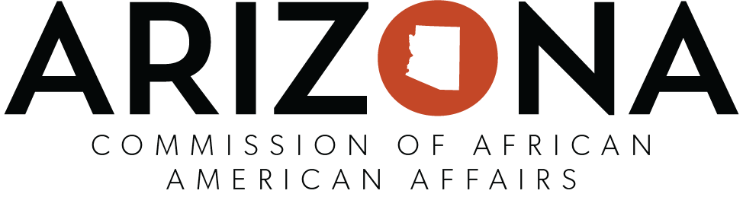
Notice of Public Meeting
Pursuant to Arizona Revised Statutes (A.R.S)38-431.02, notice is hereby given to members of the Arizona Commission of African American Affairs Commission and the general public that the Commission will hold a meeting, open to the public 11:00 am on Thursday, April 22 .Due to Covid-19 Protocol, the meeting will be held virtually. Here is the link for the Google meet meet.google.com/phz-bwnu-mey if you would like to dial-in the number is +1 929-256-1053‬ and the PIN is 355 971 607‬# ‬ Pursuant to A.R.S 38-431.03(A)(3), the Commission may vote to go into Executive Session , which will not be open to the public, for legal advice concerning any item on the agenda.

