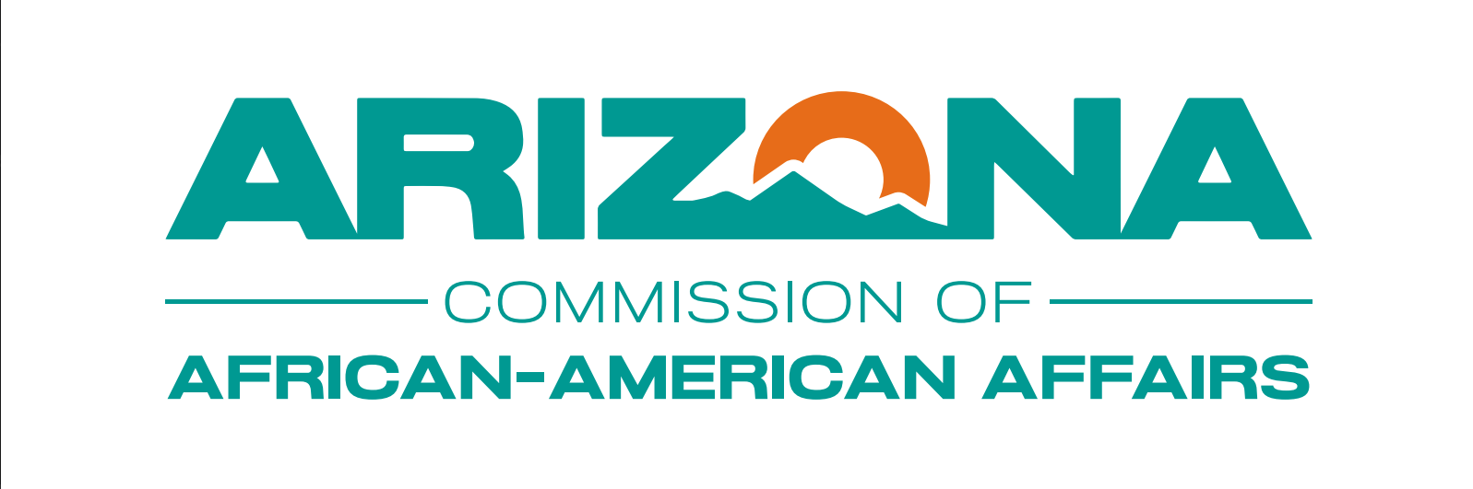

**Arizona Commission of African American Affairs**

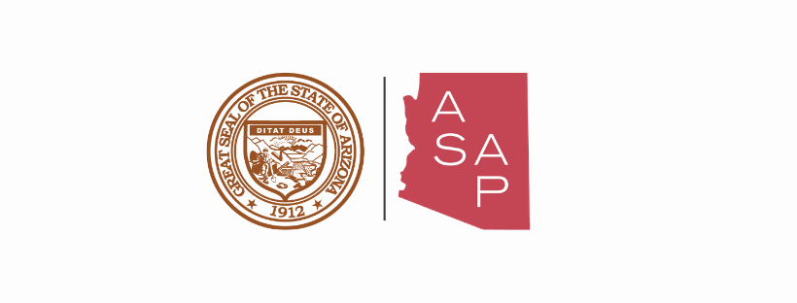Courtesy Notice:

This notice is a courtesy to inform the public that a quorum of the Arizona Commission of African American Affairs members may attend the Strategic Planning Meeting on December 6, 2024, at 9 AM at Conference Room 104 located at 1700 W Washington St, Phoenix, AZ 85007. The Council/Commission will not discuss, propose, or take legal action at this invite-only event.

Dated this 5th day of December 2024.